

UNIT INFORMATION
COURSE – (LEADING TO) | BSC (HONS) IN SOFTWARE ENGINEERING
UNIT NAME | Object Oriented Design Patterns II
UNIT ID | JIAT/OODP II
ASSIGNMENT ID | JIAT/OODP II /EX/01
STUDENT INFORMATION
STUDENT NAME | Dhanushka Madhuranga Pathiranage
STUDENT ID | 2025/2026/IIC/SE/I2/095
BATCH | Cohort 8
BRANCH | Colombo

Contents
1. Introduction and Scenario Overview
2. Part A: Dynamic Security Wrappers for Data Streams (Decorator)
3. Part B: Hierarchical Structure of Smart Zones (Composite)
4. Part C: Escalation of Citizen Complaints (Chain of Responsibility)
5. Part D: Efficient Management of Smart Street Lights (Flyweight)
6. Part E: Interpreting City Policies Defined in DSL (Interpreter)
7. System Architecture and Implementation Verification
8. Conclusion and References
Appendix A: Source Code Screenshot Catalog

1. Introduction and Scenario Overview
SmartCity360 is a municipal platform designed for Metropolis Neo-Prime. It brings together several city services, including energy-meter data, zone management, citizen complaints, smart streetlights and municipal policies. For this assignment, I designed, implemented and tested five backend subsystems using Java 17. Each subsystem applies a different Gang of Four (GoF) design pattern. While planning the system, I considered how difficult it would become to maintain if the features were built mainly with procedural code or large inheritance hierarchies. That approach could lead to deeply nested conditions, tightly connected components and performance problems. Using suitable design patterns helped me separate the responsibilities and keep the main services independent of changes in city requirements.
Part | Scenario | Pattern | Core problem solved
A | Security layers on energy-meter streams | Decorator | Add or remove compression, encryption and authentication without changing core logic
B | City → district → street → building zones | Composite | Apply one command uniformly at any level of the hierarchy
C | Complaint escalation by severity | Chain of Responsibility | Route requests through staff, supervisors and managers without coupling the sender to them
D | 25,000 street lights | Flyweight | Share identical hardware data to minimise memory
E | City policies written in a mini-language | Interpreter | Parse and evaluate rules at runtime without recompiling

Sections 2 to 6 explain how I applied each pattern. For every subsystem, I discuss why the pattern was selected, how its classes work together, and what trade-offs I found during implementation and testing. The reference implementation uses Java 17 with MySQL for persistence. The pattern classes are organised under the `com.smartcity.pattern.*` packages. I also created 35 standalone automated tests to check the main behaviour and architectural requirements. All 35 tests passed, as explained in Section 7.3.

2. Part A: Dynamic Security Wrappers for Data Streams
The smart grid receives a continuous stream of readings from energy meters across the city. These meters communicate through different networks, including secure municipal fibre connections and public 4G/5G networks. The security requirements can therefore change depending on where the data is travelling. The ingestion pipeline needs to support compression, encryption and authentication when required, without changing the code responsible for reading data from the meters.

A.1 Identification and Justification
Selected pattern: Decorator (structural; Gamma et al., 1994). Decorator allows an existing object to be wrapped by another object that implements the same interface. Each wrapper can add a processing step and then pass the call to the object inside it. I selected this pattern for three main reasons.
- Using inheritance for every possible combination would quickly become difficult to manage. A stream might need GZIP compression, AES-256-GCM encryption, HMAC-SHA256 signing, or a combination of these features. With three optional features, inheritance would require up to 2^3 = 8 different subclasses to represent every combination. Adding a fourth feature would increase that number to 16, and a fifth would increase it to 32. Decorator avoids this growth. The implementation only needs the StreamData interface, the EnergyStreamData component, an abstract decorator and one concrete decorator for each feature. The required combinations can then be created at runtime by wrapping the objects in different orders.
- This structure also supports the Open/Closed Principle discussed by Martin (2008). EnergyStreamData.java is responsible for providing the original meter data; it does not need to know how compression or encryption works. If the city's security requirements change, I can add another decorator without modifying the existing ingestion class. This keeps the original component simpler and reduces the chance of affecting code that already works.
- Another reason for choosing Decorator is that the required processing can change while the application is running. For example, a gateway using a metered cellular connection may enable GZIP compression to reduce the amount of data sent. Encryption can also be added when data passes through a public network. These combinations can be assembled when needed instead of being fixed in subclasses.
I also considered other approaches. Strategy is useful when an application needs to switch between algorithms, but it does not naturally provide a stack of independent processing steps. Proxy is mainly concerned with controlling access to an object, rather than adding transformations to its data. Adding several configuration flags to the main class would make it responsible for too many things. Decorator was a better fit because each transformation remains separate, can be combined with the others and can be tested on its own.

A.2 Flexible, Layered Stream Enhancement Mechanism
The main interface is StreamData. It declares getData(), getPayloadBytes(), getPayloadSize() and getDescription(). Both EnergyStreamData and the abstract StreamDataDecorator implement this interface. The decorator keeps a reference to the StreamData object it wraps and, by default, forwards calls to that object. Since every decorator follows the same interface, I can combine them into a chain of any required length:
StreamData s = new EnergyStreamData("STR-101", 230.5, 14.2, 3.27);
s = new CompressionDecorator(s); // 1. GZIP
Each decorator processes the result from the layer beneath it. The components that use the pipeline still work with a StreamData reference, so they do not need to know which wrappers have been added. During implementation, I had to pay attention to three details.
The order of the decorators is important. Compression needs to happen before encryption. AES-GCM produces ciphertext that looks random, so GZIP cannot find the repeated patterns it normally uses to reduce the size of JSON data. Compressing after encryption would therefore add processing without providing useful bandwidth savings. For that reason, the pipeline compresses the original JSON before encrypting it.
For encryption, EncryptionDecorator uses authenticated AES-256-GCM. A new 12-byte cryptographic nonce (IV) is generated for each packet, together with a 128-bit authentication tag. This provides confidentiality and allows the receiving side to detect changes to the ciphertext or IV. If tampering is detected during decryption, the operation fails with an AEADBadTagException (Dworkin, 2007).
- Order matters: compression has to run before encryption. AES-GCM outputs high-entropy ciphertext that looks like random white noise to standard compression tools. Because algorithms like GZIP rely on finding repetitive character sequences in plaintext JSON, running GZIP on encrypted data gives zero bandwidth savings while burning CPU cycles. That is why our pipeline always compresses raw JSON before running the cipher.
- For security, EncryptionDecorator uses authenticated AES-256-GCM. I generate a fresh 12-byte cryptographic nonce (IV) for every packet alongside a 128-bit authentication tag. This ensures confidentiality while guaranteeing that any in-transit tampering with the ciphertext or the IV throws an immediate AEADBadTagException during decryption (Dworkin, 2007).
- AuthenticationDecorator adds an outer HMAC-SHA256 value calculated over the JSON envelope, including the cipher parameters and IV (Krawczyk et al., 1997). The HMAC key is kept separate from the AES decryption key. This means an edge router can check whether a packet came from an authorised sender without having access to the key needed to decrypt its contents. AES-GCM already provides an integrity check, but the additional HMAC gives the system another way to reject unauthorised traffic before it reaches the main backend services.

Figure 2.1: UML class diagram, Decorator pattern (Part A)

Figure 2.2: Stream wrapping pipeline

A.3 Long-Term Benefits: Reusability, Extensibility, and Overhead
Each transformation is implemented in a separate class, so the decorators do not depend directly on one another. Different city gateways can combine the same classes according to their requirements. For example, a high-voltage substation can use compression, encryption and HMAC together. A temperature sensor on a private fibre network may only need compression, while a public air-quality feed may use HMAC authentication. This avoids writing separate implementations for each type of endpoint.
The design also makes future changes easier. If the city later requires post-quantum digital signatures, I can add a new decorator that extends StreamDataDecorator. The meter polling code, database layer and REST controllers would not need to change. Since the rest of the application works with the StreamData interface, the new feature can be introduced without changing the existing consumers.
I measured the payload size at different stages during testing. A single-reading JSON payload of 72 bytes increased to 92 bytes after GZIP because the compression header and trailer added more data than could be removed from such a small message. After Base64 encoding and adding the 12-byte IV, GCM authentication tag and 64-character HMAC value, the final packet reached 468 bytes. The result was different when readings were sent in batches of 1 KB to 64 KB. In those cases, GZIP could use repeated JSON field names and reduce bandwidth by around 65% to 75%. Based on these measurements, buffering readings and compressing them in batches is more suitable than compressing every small reading separately.
Separating the processing stages also makes testing and maintenance more manageable. I can test compression, encryption and authentication individually before testing the complete pipeline. If the project later moves from GZIP to Zstandard, for example, the change should be limited to the relevant decorator. With an inheritance-based design, the same logic could be repeated across several combined subclasses, making updates and regression testing more difficult.
Decorator is not without disadvantages. Every wrapper creates another object, and the compiler does not check whether the decorators have been arranged in the correct logical order. An incorrectly ordered pipeline can still compile but may reduce compression performance. Debugging can also involve several nested calls, and checking the type of the outer decorator does not reveal the wrapped component directly. I reduced these risks by using factory methods to assemble pipelines and by writing tests 01 to 06 for decompression, decryption, tamper detection and key validation.

3. Part B: Hierarchical Structure of Smart Zones
The city's geographical structure is naturally hierarchical. The metropolitan area is divided into districts, each district contains street corridors, and the streets contain individual buildings. Grid operators need to send commands such as emergency load shedding and usage reports to any part of this hierarchy. The implementation should support commands at different levels without requiring a separate traversal algorithm for each level.

B.1 Identification and Justification
Selected pattern: Composite (structural; Gamma et al., 1994). The city's zones form a tree, with smaller areas grouped under larger areas. Composite allows the application to use the same interface, ZoneComponent, when working with a single building or with a larger group such as a district containing several streets.
- One benefit is that commands can be handled consistently throughout the hierarchy. BuildingLeaf and ZoneComposite both implement ZoneComponent, so a controller does not need to decide whether it is dealing with one building relay or a group of zones. It can call the same operation in either case.
- Without Composite, the controller would need to check the type of each zone using conditions such as `instanceof City` or `instanceof District`. Those checks would become harder to maintain whenever another administrative level was introduced. With this design, the client calls zone.executeCommand(ZoneCommand.SHUTDOWN_POWER), and the composite passes the command down through its children until it reaches the building leaves.

B.2 UML Class Diagram and Recursive Mechanism

Figure 3.1: UML class diagram, Composite pattern (Part B)
The design has three main parts. ZoneComponent defines operations such as executeCommand(), getPowerConsumption() and getStatus(), together with the child-management methods add(), remove() and getChildren(). BuildingLeaf represents an individual building and communicates with its hardware relay. ZoneComposite stores a List<ZoneComponent> and forwards operations to the components it contains.
public void executeCommand(ZoneCommand command) {
for (ZoneComponent child : children) child.executeCommand(command);
}

B.3 Scalability for Expanding Municipal Topologies
The main benefit is that a command can travel through the hierarchy recursively. For example, when an operator starts load shedding at the city level, the command passes through the districts and streets before reaching the individual building relays. This is a depth-first traversal with O(M) time complexity for M nodes in the affected branch. The controller uses the same operation whether the target is one building or a group containing thousands of facilities.
The hierarchy can also be extended without changing the controller logic. If the municipality adds an industrial park, residential sector or solar farm, the new zones can be attached to the existing tree. A new type of branch, such as MetroTransitComposite, only needs to implement ZoneComponent. This makes it possible to add new parts of the city while keeping the existing client code unchanged.
Power usage can be retrieved in the same way. A BuildingLeaf returns the current consumption of its own facility, while a ZoneComposite adds together the values returned by its children. The dashboard can therefore request consumption from a building, street, district or the whole city using the same method.
I also added checks to prevent invalid tree structures. A call to add() on a BuildingLeaf throws UnsupportedOperationException because a leaf cannot contain children. ZoneComposite rejects null children, prevents a node from being added to itself and checks for circular references that could otherwise cause infinite recursion. The cycle checks are covered by tests 13 and 27. An invalid command string also produces an exception that explains which commands are accepted, as checked in test 12.
During a power-grid emergency, an operator could use EMERGENCY_ISOLATE to disconnect an overloaded district, then use REPORT_USAGE to inspect the remaining power consumption. Once the situation is resolved, RESTORE_POWER can be used to bring the district back online. Each building returns to its own baseline wattage rather than being assigned one shared default value. Tests 09 and 10 verify this behaviour.
One limitation is that add() and remove() are included in the ZoneComponent interface even though building leaves cannot support these operations. This makes the interface consistent, but it means a leaf can receive a method call that it cannot perform. Throwing UnsupportedOperationException makes this misuse visible during development. Another limitation is that commands run synchronously. If a network problem occurs partway through a broadcast, the system does not automatically roll back changes already made to earlier nodes. That would require additional transaction or recovery handling. For the four-level hierarchy in this project, I considered these trade-offs acceptable because the pattern avoids repeated traversal logic in the controllers.

Figure 3.2: Zone tree and command broadcast

4. Part C: Escalation of Citizen Complaints
Residents of Metropolis Neo-Prime can submit complaints about many different issues, from potholes to serious incidents such as gas leaks and transformer failures. The ticketing system must assess each complaint and send it to the appropriate level of staff. A case may move from the customer service desk to a supervisor and then to a city manager, depending on its severity. The system must also keep a record of the decisions made during this process.

C.1 Identification and Justification
Selected pattern: Chain of Responsibility (behavioral; Gamma et al., 1994). The pattern passes a request through a sequence of linked handler objects. Each handler decides whether it can deal with the request or whether it should pass it to the next handler.
- This separates the submission of a complaint from the process of handling it. A citizen or API controller only needs to submit the complaint to the beginning of the chain. It does not need to know which staff member or department will eventually take responsibility for the case.
- The chain can also be changed when different routing requirements arise. Handlers are connected through setNext(), so another stage can be added or the order can be adjusted. For example, an emergency dispatch handler could be placed near the start of the chain during a storm alert without requiring changes to the existing complaint-submission code.
- Each handler has one main responsibility. It checks the complaint against the severity rules for its administrative level and either handles the case or passes it on. This keeps the routing logic from becoming one large method containing every department's rules.

C.2 Decoupled Request Handling and Dispatch Mechanism
The abstract ComplaintHandler class is the base for the routing stages. It stores a reference to nextHandler, provides setNext() for connecting handlers and defines the handle(Complaint) operation. ComplaintChainFactory creates the default sequence used by the backend:
ValidationTriage -> LocalStaff -> Supervisor -> CityManager -> TerminalFallback
Handler | Takes | Outcome
ValidationTriageHandler | Missing or invalid severity | Role TRIAGE_DISPATCH_OFFICER, status VALIDATION_REQUIRED; never defaults to LOW
LocalStaffHandler | LOW | Status ASSIGNED (routine maintenance)
SupervisorHandler | MEDIUM | Status ESCALATED_SUPERVISOR (e.g. water leaks, signal faults)
CityManagerHandler | HIGH, CRITICAL | Status EXECUTIVE_ESCALATION; CRITICAL gets crisis mobilisation notes
TerminalFallbackHandler | Anything unresolved | Role FALLBACK_DISPATCH_DESK, status FALLBACK_ASSIGNED, with audit record

Consider a resident who reports a CRITICAL gas leak. The complaint first reaches ValidationTriageHandler, which checks that the submitted information is valid and that the severity is recognised. LocalStaffHandler and SupervisorHandler then examine the complaint, but the severity is outside their authority, so they pass it onwards. CityManagerHandler receives the case and marks it as EXECUTIVE_ESCALATION. Each handler adds an audit record, creating a chronological history of how the complaint was routed. The intake API does not need to know the details of the management structure.
I added ValidationTriageHandler after identifying a problem with the way missing severity values could be handled. In the earlier approach, a complaint with a blank severity could be treated as LOW. That could send a dangerous incident, such as a gas leak, into the normal maintenance queue. In this implementation, a complaint with missing or invalid severity is stopped at the first stage and sent to a human triage officer instead.

Figure 4.1: UML class diagram, Chain of Responsibility (Part C)

C.3 Architectural Evaluation: Flexibility, Auditability, and Trade-offs
The main advantage of this design is that departments can use different routing arrangements without changing the complaint intake controller. Public Works, Transport and Environmental Safety, for example, can create their own chains with different severity thresholds by using the factory methods. Replacing a large set of switch statements with individual handler classes also makes it easier to add another administrative level: a new handler can be created and connected to the chain.
The pattern also supports accountability. Each dispatch returns a ComplaintRoutingResult with an unmodifiable list of ComplaintAuditRecord entries. The records contain the handler class, staff role, ISO-8601 timestamp, decision and reason for that decision. This allows an auditor to follow the route taken by a complaint, such as Triage → Staff → Supervisor → Manager. Test 21 checks this audit trail.
Drawbacks.
- There are some costs to this approach. The time required to process a request increases with the number of handlers because each stage performs checks and records its decision. A complaint that passes through five handlers will take longer than one direct lookup, although this additional work is small for the expected volume of municipal complaints.
- Debugging can be less straightforward than in a single procedural method. A request moves through several calls, so a routing problem may require checking both the individual handlers and the way the chain was connected.
- A complaint could also reach the end of the chain without being handled. To avoid leaving such requests unresolved, I added TerminalFallbackHandler as the final stage. The normal chain should handle all recognised severities before reaching this point, but the fallback is useful when a custom chain has missing stages. Test 20 verifies this behaviour.
- The chain must be connected correctly, and creating an audit object at every stage adds a small amount of garbage-collection work when complaint volumes are high. For this system, I consider those costs reasonable because the design keeps the handlers separate and provides a clear record of each routing decision.
Overall, the flexibility and audit history are more valuable here than saving a very small amount of processing time. In a municipal complaint system, being able to explain how a case was handled is an important requirement.

Figure 4.2: Complaint routing flow

5. Part D: Efficient Management of Smart Street Lights
Metropolis Neo-Prime has a network of 25,000 smart LED streetlights. Each pole has its own identifier and GPS location, but many poles use the same hardware model, wattage, lumen output and firmware version. Storing all of these repeated specifications separately for every pole would use unnecessary memory. The backend therefore needs a way to represent the fleet without creating excessive heap usage or frequent garbage-collection pauses.

D.1 Identification and Justification
Selected pattern: Flyweight (structural; Gamma et al., 1994). If the system created a completely independent object for every one of the 25,000 lights, it would repeatedly store the same hardware information. The Flyweight pattern reduces this duplication by placing common, unchanging properties in shared profile objects. Each pole then keeps only its own location and operational information, together with a reference to the shared profile.

D.2 Handling Shared (Intrinsic) and Unique (Extrinsic) Properties
- • Intrinsic state (shared, immutable hardware specifications): model, lampType, wattage, maxLumens, colorTemperatureK, and firmwareVersion. This data lives in a SharedStreetlightProfile object, created and cached once by StreetlightProfileFactory.
- • Extrinsic state (unique, mutable context per pole): poleId, latitude, longitude, brightnessLevel, and operational status. This data resides in a lightweight StreetlightContext object, which keeps a pointer back to its shared hardware profile.
StreetlightProfileFactory uses a ConcurrentHashMap to store and retrieve shared profiles. It builds a key from the hardware specifications and uses computeIfAbsent() to create a profile only when one does not already exist. This also makes profile lookup and creation safe when several ingestion threads access the factory at the same time (Goetz et al., 2006):
String key = model+"|"+lampType+"|"+wattage+"|"+maxLumens+"|"+colorTemp+"|"+firmware;
return cache.computeIfAbsent(key, k -> new SharedStreetlightProfile(...));
Tests 22 to 25 check that the factory reuses a profile when the hardware specifications are identical and creates a different profile when the specifications differ. They also check that eight concurrent worker threads still obtain a single shared instance, and that changing one pole's brightness does not modify the shared hardware profile.

Figure 5.1: UML class diagram, Flyweight pattern (Part D)

D.3 Performance Impact: Memory Layout, GC, and Object Overhead
To estimate the memory difference, I used an object-layout model for a 64-bit HotSpot JVM with Compressed OOPs. In this model, a normal pole object uses approximately 288 bytes, including its object header, primitive fields, five string references and the backing character arrays. With Flyweight, each StreetlightContext is estimated at 80 bytes, while a shared SharedStreetlightProfile uses 208 bytes. These are the values used in FlyweightBenchmark.java:
- • Naive memory footprint: 25,000 * 288 B = 7,200,000 B (6.87 MiB).
- • Flyweight memory footprint: 25,000 80 B + (3 profiles 208 B) = 2,000,624 B (1.91 MiB).
- • Net memory reduction: (7,200,000 - 2,000,624) / 7,200,000 = 72.2%.
When scaling from 1,000 up to 100,000 poles in OpenJDK 17 benchmarks, heap usage grows linearly in both setups:
Poles | Naive (layout) | Flyweight (layout) | Reduction | Naive time | Flyweight time
1,000 | 0.27 MB | 0.08 MB | 71.99% | 11 ms | 12 ms
10,000 | 2.75 MB | 0.76 MB | 72.20% | 16 ms | 14 ms
25,000 | 6.87 MB | 1.91 MB | 72.21% | 16 ms | 18 ms
100,000 | 27.47 MB | 7.63 MB | 72.22% | 52 ms | 65 ms

Both approaches still use more memory as the number of poles increases, but the Flyweight design grows more slowly. Its estimated memory use is about 28% of the unoptimised design because the number of shared profiles depends on the number of hardware models, not the number of poles. The percentage saved remains close to 72.2% in these measurements, while the total amount of memory saved becomes larger as more lights are added. The shared-profile lookup introduces a small amount of extra work, but the memory reduction makes that trade-off worthwhile for this fleet.
I also compared the layout estimates with heap measurements taken at runtime after calling System.gc(). The naive fleet used 4.80 MB, while the Flyweight version used 2.63 MB, which is a 45.1% reduction. This result is lower than the 72.2% estimated from the object layout because a runtime heap measurement also includes JVM data such as internal buffers, thread stacks and class metadata. The two measurements use different methods, but both show a reduction in memory usage.
The shared profiles are held in the factory's static cache and remain available for the lifetime of the process. The main benefit for garbage collection is that the application creates fewer repeated objects in the young generation. This can reduce minor collection activity during periods when the system is receiving many streetlight updates (Oracle, 2024).
The pattern depends on keeping shared profiles immutable. If one of their fields changed, every streetlight using that profile would be affected. Flyweight is also less useful when almost every pole has unique hardware specifications, because the cache would add references without providing much sharing. In a distributed deployment, profile information would also need to be kept consistent between JVM instances.

Figure 5.2: Estimated heap for 25,000 streetlights

6. Part E: Interpreting City Policies Defined in DSL
City rules can change when the council updates requirements for noise levels, air quality or streetlight schedules. The platform needs to evaluate these rules against incoming sensor readings without restarting the server or recompiling the Java application each time a policy changes.

E.1 Identification and Justification
Selected pattern: Interpreter (behavioral; Gamma et al., 1994). Interpreter represents the grammar of a small language through a set of expression classes. These classes form an Abstract Syntax Tree (AST), which can then be evaluated against a context. For example, a city policy could be written as `((NOISE_LEVEL > 75.0) AND (CURRENT_HOUR >= 22.0)) OR (AIR_QUALITY_AQI > 150.0)`. This pattern suits the project because the policy language only needs a limited set of Boolean and comparison operations. It also avoids executing general-purpose scripts through engines such as JavaScript eval() or Groovy, which would introduce additional security concerns. The rules are evaluated by the application's own AST classes.

E.2 UML Class Diagram and Parsing Mechanism

Figure 6.1: UML class diagram, Interpreter pattern (Part E)
The policy engine has four main parts. PolicyContext stores sensor values such as NOISE_LEVEL and looks up variable names without case sensitivity. The Expression interface defines interpret(PolicyContext), which returns a boolean result. TerminalExpression compares a variable with a numeric value using the supported operators (>, >=, <, <=, == and !=), with an epsilon of 0.00001 for floating-point comparisons. AndExpression and OrExpression represent the non-terminal parts of the grammar and evaluate their child expressions using short-circuit logic. DslPolicyParser converts the policy text into an AST using recursive descent. It handles tokenization, operator precedence and nested parentheses. A rule using `VAR BETWEEN a AND b` is expanded into two checks: VAR >= a and VAR <= b. To limit excessive input, the parser allows a maximum of 120 tokens and a recursion depth of 25. Invalid input results in a DslSyntaxException. For example, when NOISE_LEVEL is 78.5 and CURRENT_HOUR is 23, the rule shown above evaluates to true because both conditions are satisfied.

E.3 Critical Assessment: Rule Updates, Extensibility, and Security
Policies are stored as plain text in MySQL. When an administrator changes a bylaw through POST /api/policies, the updated text is used during the next evaluation. The parser and AST expression objects do not keep mutable request-specific state, so servlet threads can use them without sharing mutable data or needing locks. A policy change therefore does not require a Java recompilation or an application restart.
I measured the performance over 2,000 iterations after warming up the JVM on OpenJDK 17. Evaluating an AST that had already been created took 0.07 µs on average. Parsing the policy text took 1.99 µs, while parsing and evaluating it together took 2.11 µs. These results indicate that the current implementation can handle the simple rules used by the project. If the number of repeated evaluations grows, parsed ASTs could also be cached.
New grammar features can be added by implementing another Expression class. For example, a NotExpression, an InListExpression for zone membership or a geographic distance check could be introduced without rewriting the existing expression nodes. The parser would still need the corresponding grammar changes, but the expression design keeps each operation separate. Tests 28 to 35 cover the comparison operators, BETWEEN ranges, non-numeric values, nested expressions, missing context keys and five types of syntax error.
The DSL is deliberately limited and does not support reflection, file access or command execution. This reduces the ways in which a policy could affect the server beyond evaluating its permitted expressions. The tokenizer rejects unknown characters, while the token and recursion limits help prevent excessive processing. The administrative endpoints are also protected by token checks and rate limiting.
The Interpreter pattern does have recognized limitations to manage:
- Class proliferation: Each grammar rule requires an expression class. This is manageable for the current set of operations, but adding features such as loops or functions could make the class structure difficult to maintain.
- Parser maintenance: As the grammar becomes larger, manually maintaining operator precedence and error handling becomes more complicated. If the language grows significantly, a parser generator such as ANTLR or JavaCC may be a better option.
- Undefined variables: A sensor variable that is not registered evaluates to false to avoid a NullPointerException. This is safe from a runtime perspective, but it also means a spelling mistake in a policy could be treated as 'no violation' rather than reported as an invalid variable.
- Complex calculations: The current AST approach is intended for straightforward policy checks. If future rules require stateful loops or more complex algorithms, a sandboxed execution engine such as GraalVM would be more suitable.
For the current SmartCity360 requirements, the Interpreter implementation is a reasonable fit. The city policies are mainly Boolean conditions and numeric thresholds, so a small custom language keeps evaluation lightweight and avoids extra dependencies. A more advanced parsing or execution tool would only be necessary if the rules became much more complex.

Figure 6.2: AST for a sample policy

7. System Architecture and Implementation Verification

7.1 System Architecture
SmartCity360 uses a four-tier structure based on common enterprise application architecture practices (Fowler, 2002):
- Presentation Tier: The user interface is a Next.js web application. It provides dashboards for telemetry, zone maps, complaint handling, streetlights, policy rules and test results.
- API Tier: Java 17 servlets provide the REST endpoints (/api/auth, /api/streams, /api/zones, /api/complaints, /api/streetlights, /api/policies, /api/dashboard and /api/test-center). The API uses CORS filters, token checks and Gson for JSON serialisation.
- Pattern Domain Core: The five design-pattern implementations are kept in the pure Java packages under com.smartcity.pattern.*. This layer does not depend on the web framework.
- Persistence Tier: MySQL 8 stores the system's data across nine tables. Data Access Objects (DAOs) handle database operations, using connection pooling and parameterised queries to reduce the risk of SQL injection.

Figure 7.1: System architecture

Figure 7.2: Use case diagram

Figure 7.3: Complaint submission sequence diagram
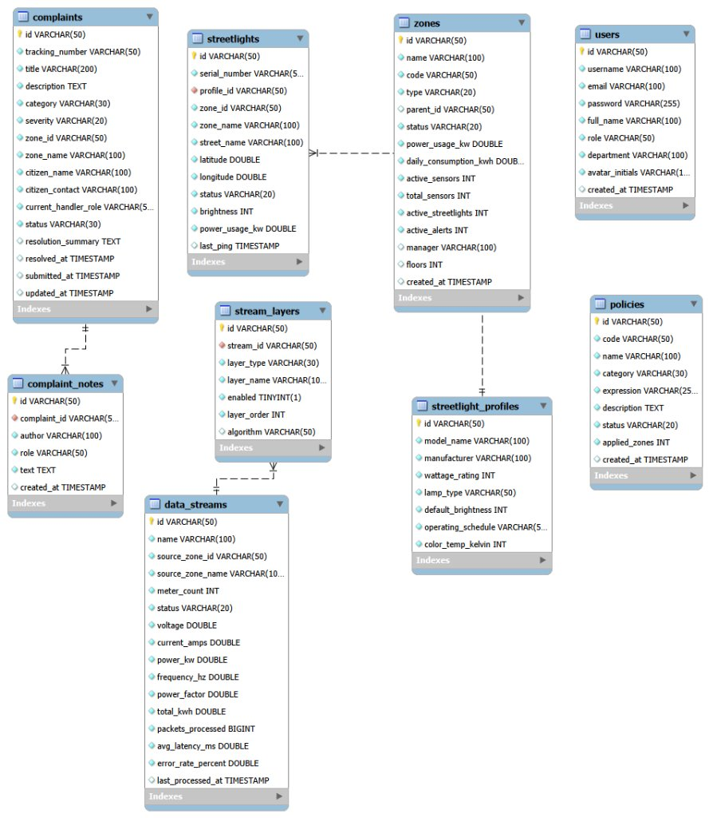
Figure 7.4: Entity-relationship diagram
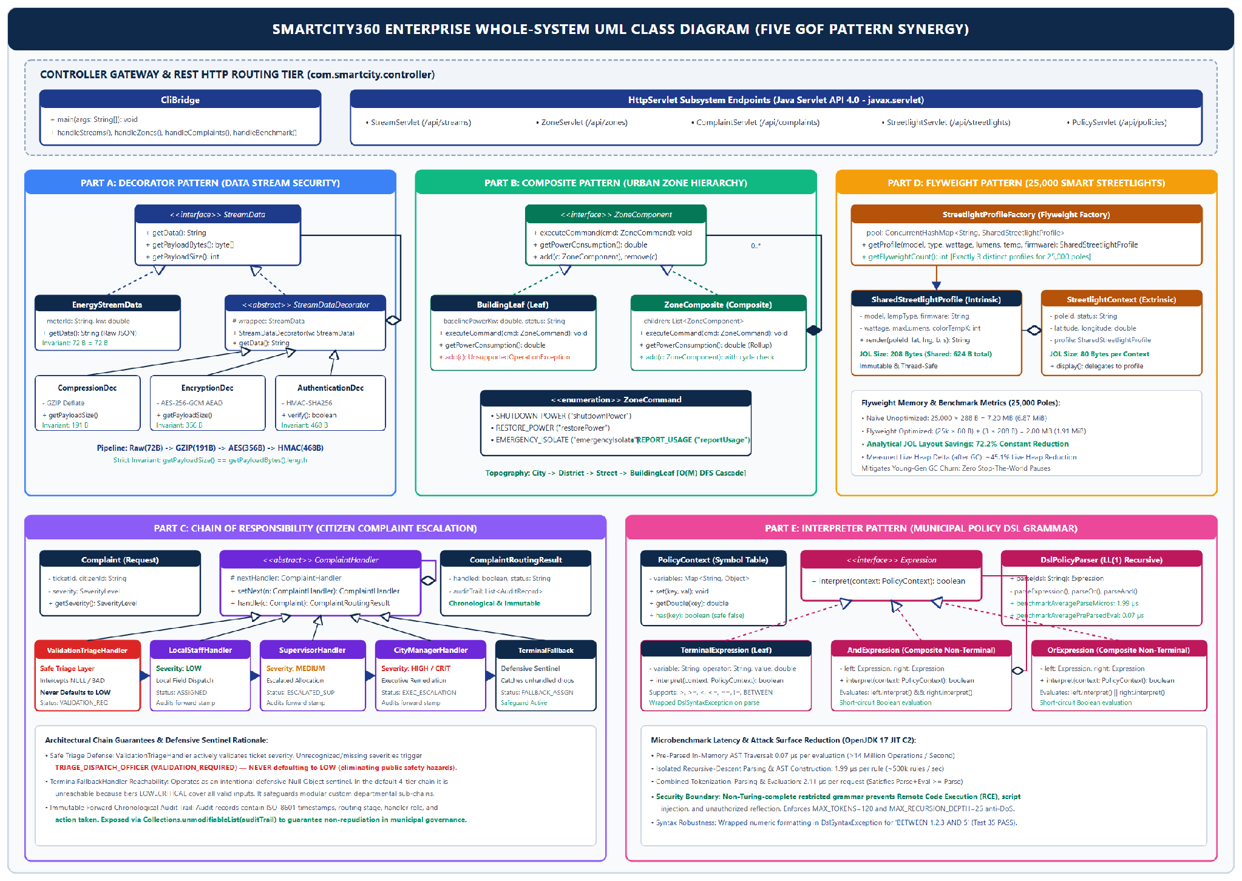
Figure 7.5: Whole-system UML class diagram

7.2 Key Architectural Choices and Anti-Pattern Mitigation
Anti-pattern | How SmartCity360 avoids it
Spaghetti code, Long method | Procedural branching is replaced by small single-purpose pattern classes (decorators, handlers, expression nodes).
God object | Responsibilities are spread across decorators, handlers and composite nodes rather than one manager class.
Copy-paste programming | Shared behaviour lives in base types: StreamDataDecorator, ComplaintHandler, ZoneComponent.
Tight coupling | Clients depend on interfaces (StreamData, ZoneComponent, Expression), not concrete classes.
Primitive obsession, Magic numbers | Enums and value objects (ZoneCommand, ComplaintSeverity, ComplaintRoutingResult) and named constants replace raw strings and literals.
Swallowed exceptions | Errors propagate as typed exceptions (DslSyntaxException, AEADBadTagException); fallback paths are recorded.

7.3 Automated Test Suite and Quality Verification
ComprehensiveTestSuite is a standalone test runner that does not depend on an external testing framework such as JUnit. It can be run on a clean JDK 17 setup and is also connected to the web-based Test Center dashboard. The suite runs 35 tests across the five pattern implementations. All 35 tests passed during verification.
Pattern | Tests | Passed | Main behaviours verified
Decorator | 6 | 6 | Pipeline order, decryption, HMAC rejection, corrupted data, invalid key
Composite | 8 | 8 | Cascade, restore, aggregation, leaf safety, cycle rejection
Chain of Responsibility | 8 | 8 | Severity routing, safe triage, fallback, audit trail
Flyweight | 5 | 5 | Instance sharing, thread safety, 72.2% layout saving
Interpreter | 8 | 8 | AST, BETWEEN, nesting, missing variables, malformed syntax
Total | 35 | 35 | 100% pass rate
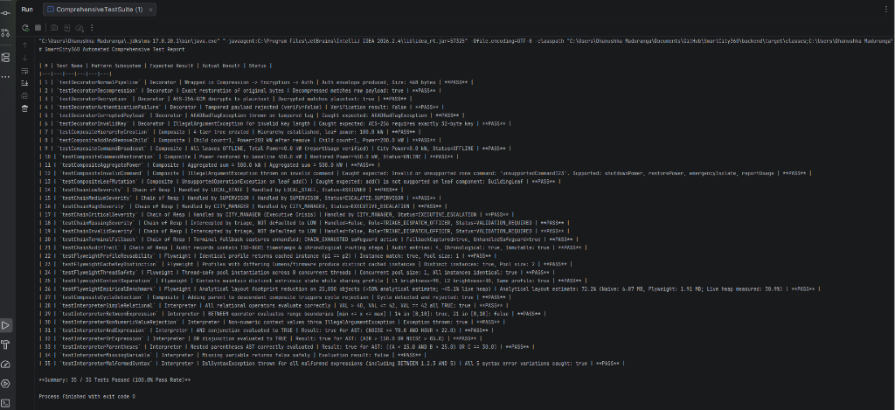
Figure 7.6: Live execution of ComprehensiveTestSuite in IntelliJ IDEA (35/35 passing)

8. Conclusion and References

8.1 Conclusion
The five Gang of Four patterns in SmartCity360 each address a different part of the municipal platform. Decorator allows security and compression steps to be combined around energy streams. Composite provides a consistent way to manage the city's zone hierarchy. Chain of Responsibility routes complaints through the appropriate staff levels. Flyweight reduces duplicated data across the 25,000 streetlights, while Interpreter evaluates changing city policies through a small domain-specific language. During implementation, I also considered the limitations of each pattern, including decorator order, recursive operations and the growth of the expression classes. The 35 automated tests passed and provide evidence that the main behaviours are working as expected.
There are several possible improvements for a future version. If the policy language becomes more complex, the parser could be migrated to ANTLR. A distributed cache such as Redis could help keep Flyweight profile data in sync across multiple server nodes. Digital signatures such as ECDSA could also be added to provide stronger non-repudiation for citizen complaint records.

8.2 References
Coward, D. (2017). Java Servlet Specification, Version 4.0 (JSR 369). Oracle and Eclipse Foundation.
Dworkin, M. (2007). Recommendation for Block Cipher Modes of Operation: GCM and GMAC. NIST SP 800-38D.
Fowler, M. (2002). Patterns of Enterprise Application Architecture. Addison-Wesley.
Gamma, E., Helm, R., Johnson, R. and Vlissides, J. (1994). Design Patterns: Elements of Reusable Object-Oriented Software. Addison-Wesley.
Goetz, B. et al. (2006). Java Concurrency in Practice. Addison-Wesley.
Krawczyk, H., Bellare, M. and Canetti, R. (1997). HMAC: Keyed-Hashing for Message Authentication. RFC 2104. IETF.
Martin, R. C. (2008). Clean Code. Prentice Hall.
Oracle. (2024). Java SE 17 Developer Documentation and HotSpot Memory Management Guide.

Appendix A: Source Code Screenshot Catalog
The source files are organised below by design pattern. The complete compilable project is included in the submitted ZIP file.

A.1 Decorator (com.smartcity.pattern.decorator)
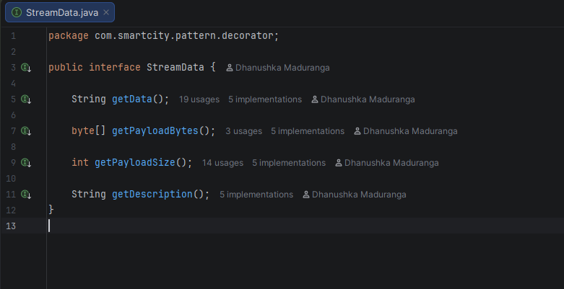  StreamData.java (component interface) | 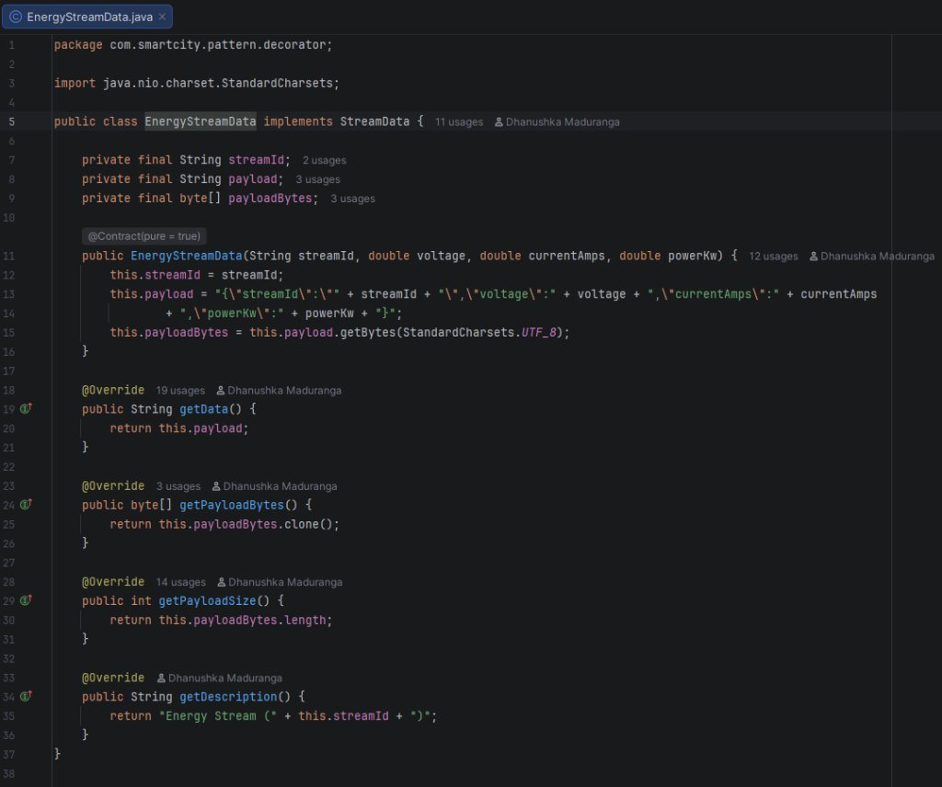  EnergyStreamData.java (concrete component)
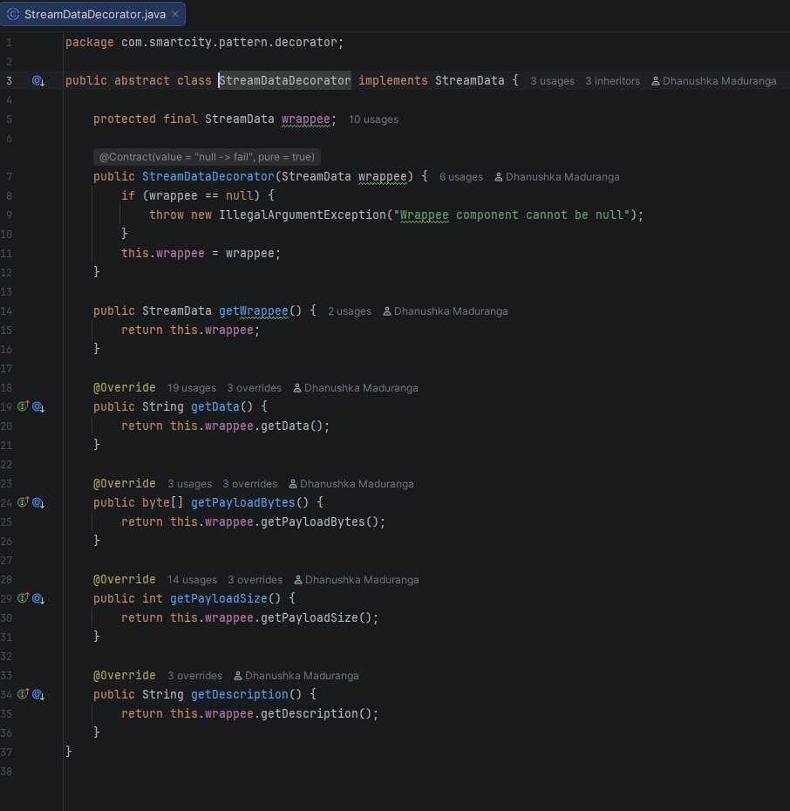  StreamDataDecorator.java (abstract decorator) | 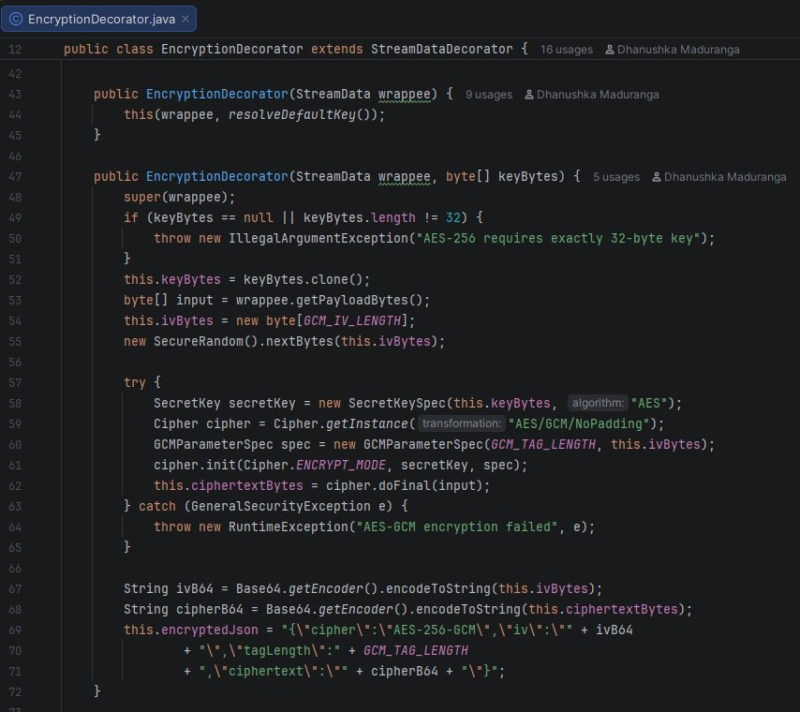  EncryptionDecorator.java (AES-256-GCM)
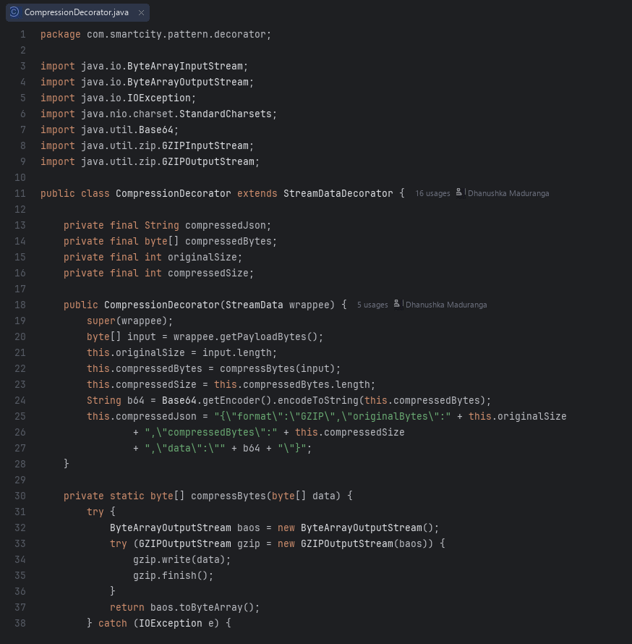  CompressionDecorator.java (GZIP) | 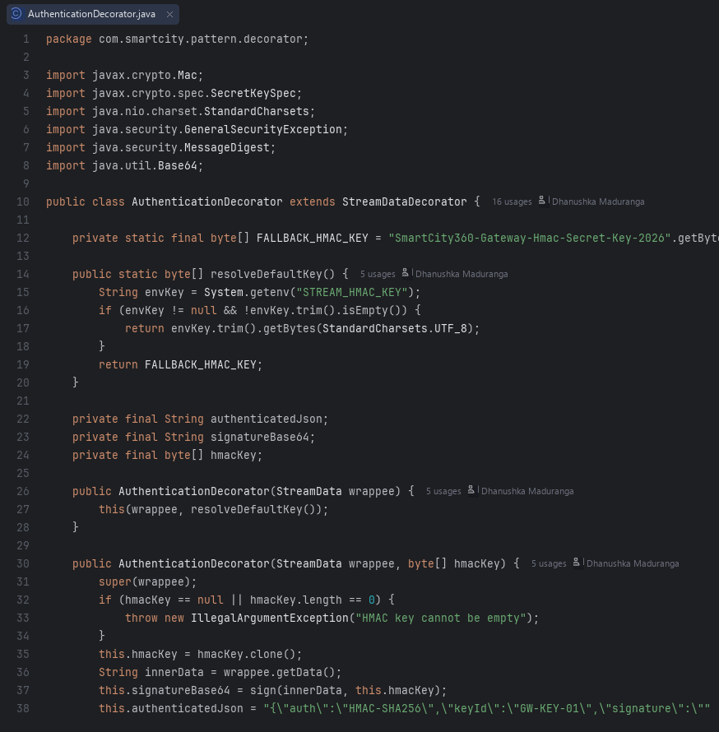  AuthenticationDecorator.java (HMAC-SHA256)

A.2 Composite (com.smartcity.pattern.composite)
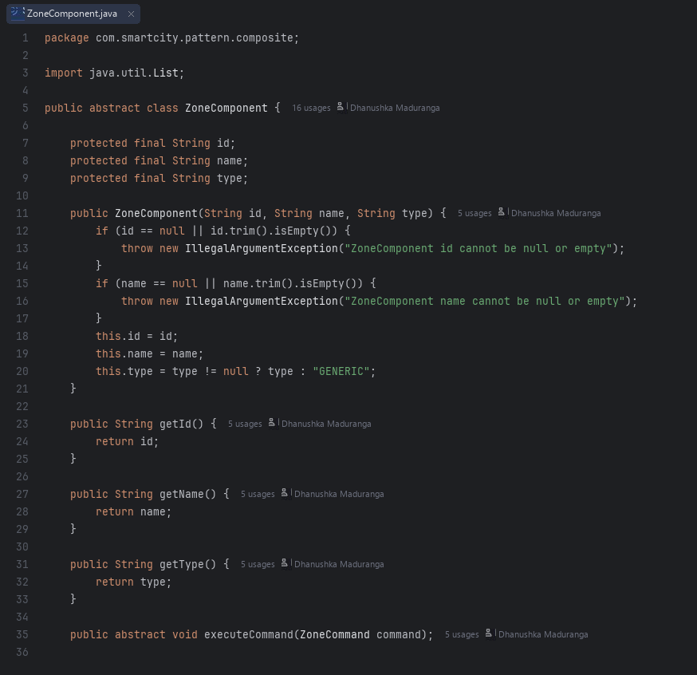  ZoneComponent.java | 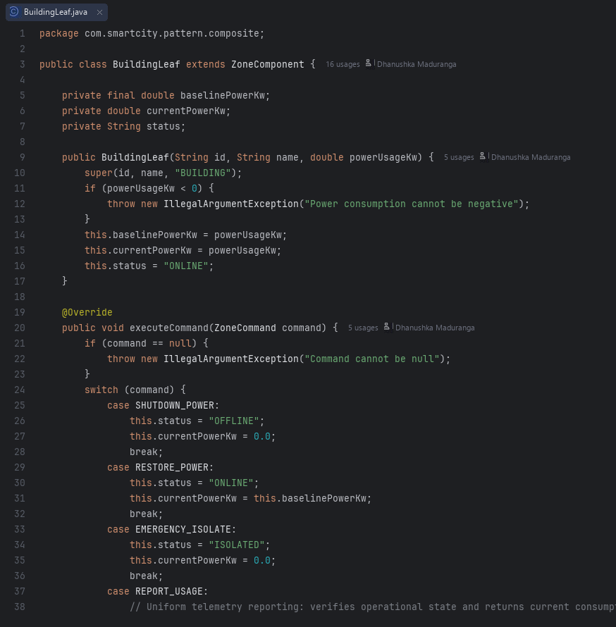  BuildingLeaf.java
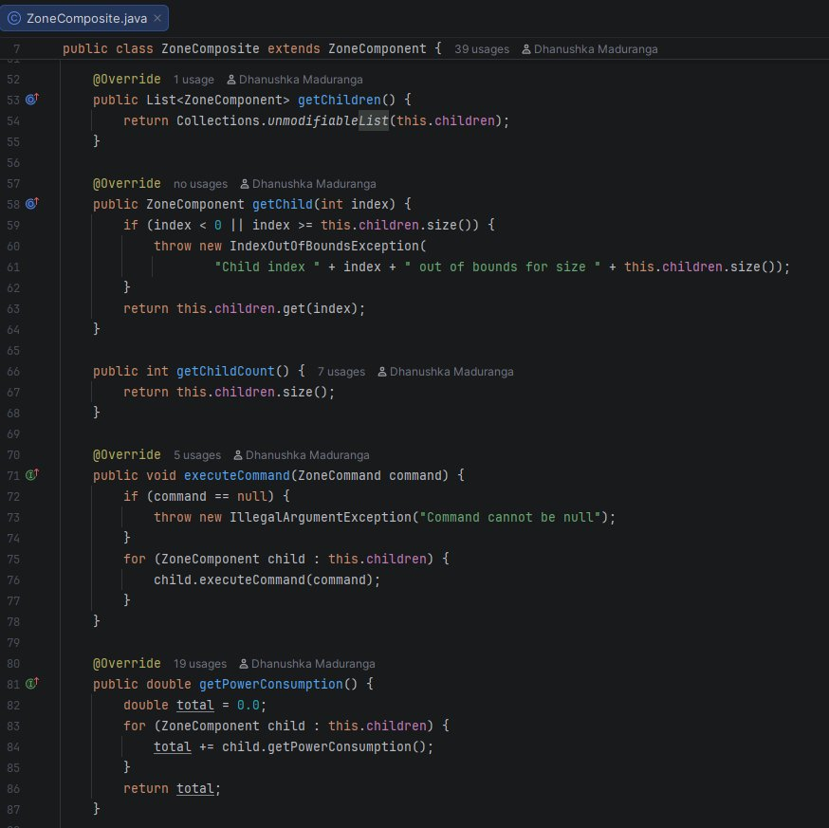  ZoneComposite.java | 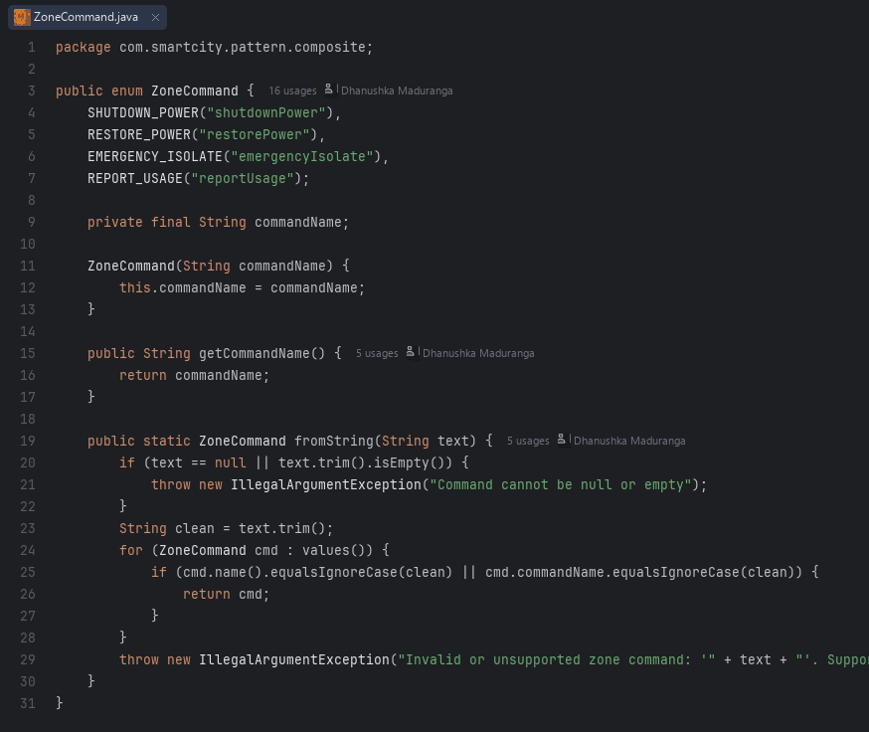  ZoneCommand.java

A.3 Chain of Responsibility (com.smartcity.pattern.chain)
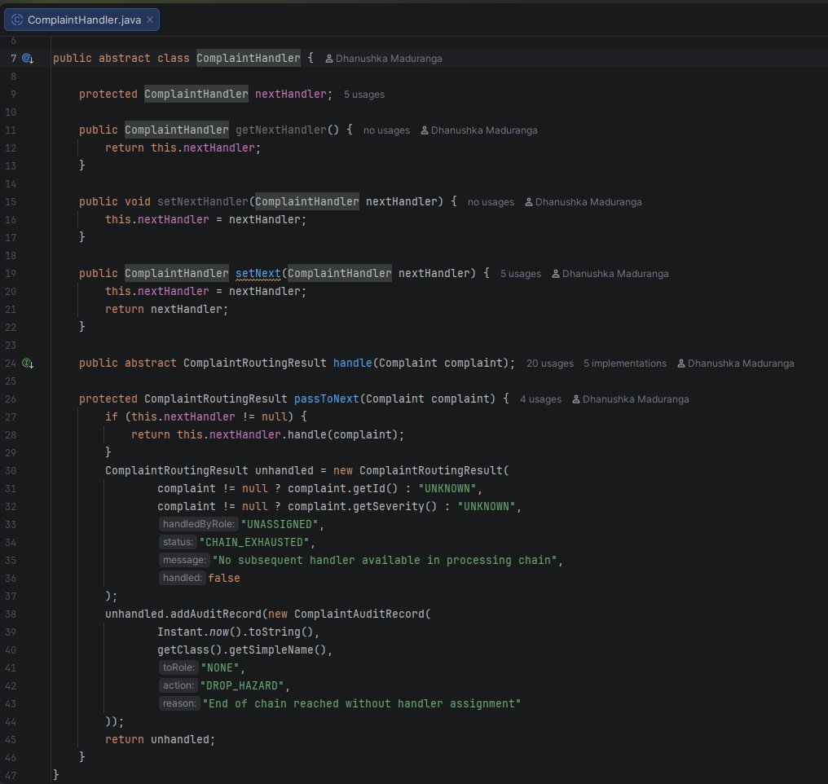  ComplaintHandler.java | 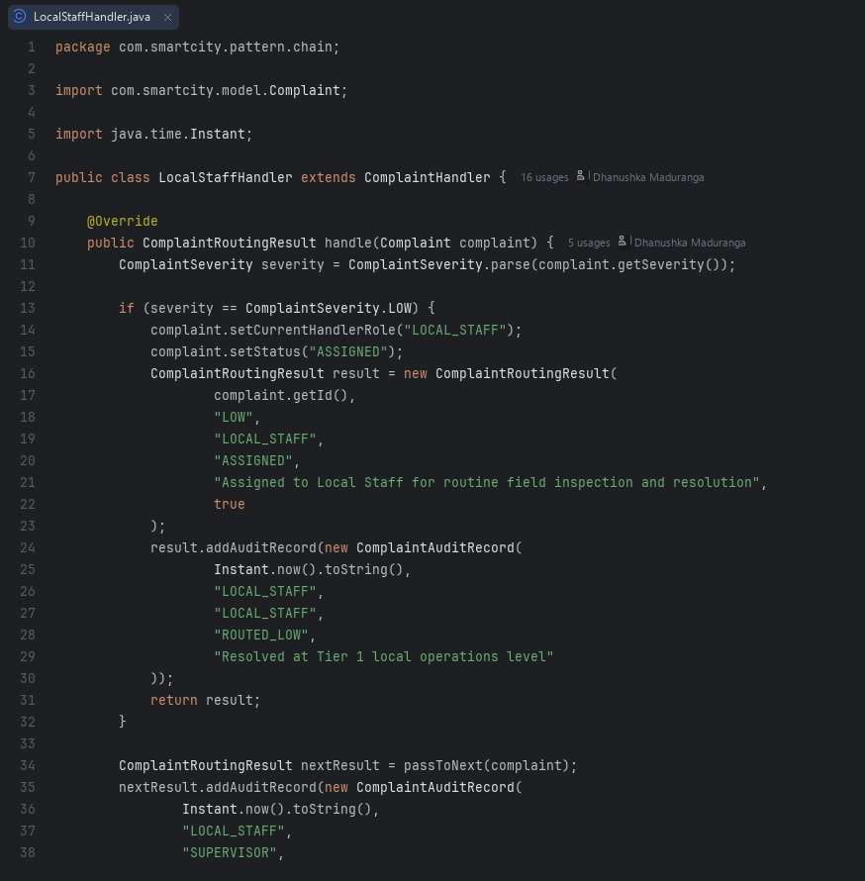  LocalStaffHandler.java
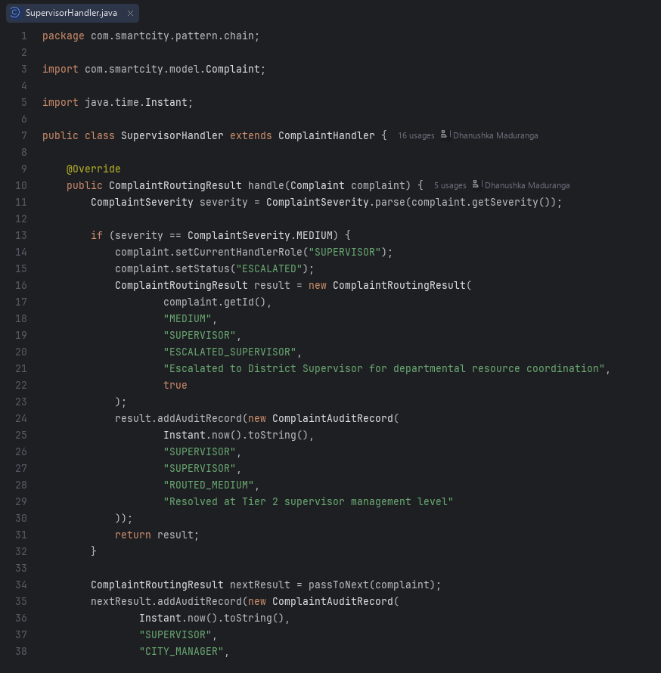  SupervisorHandler.java | 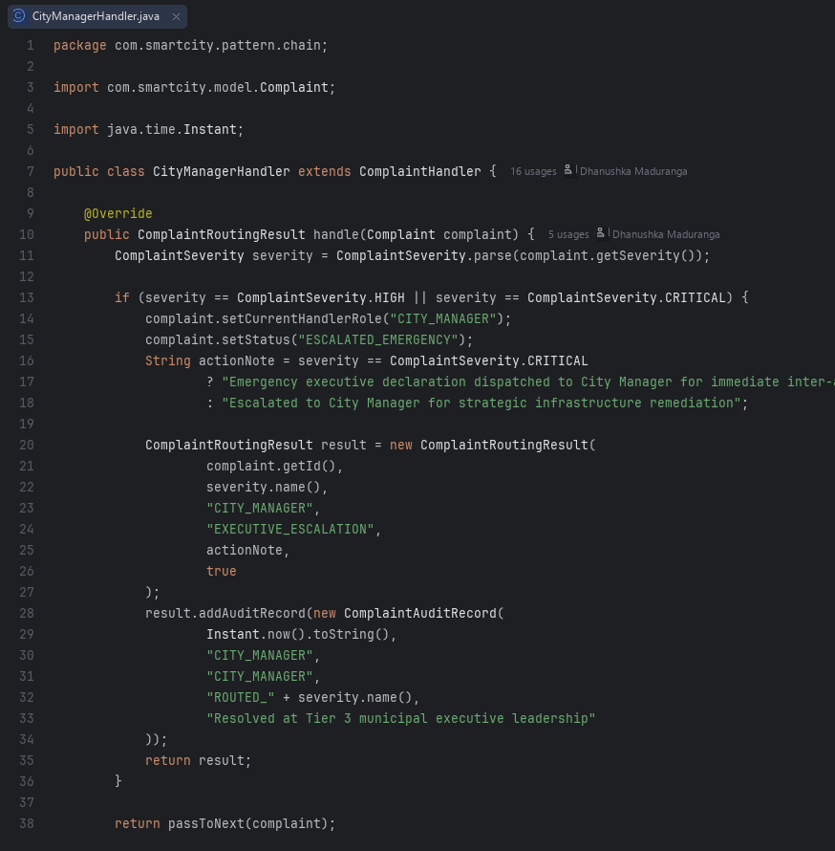  CityManagerHandler.java
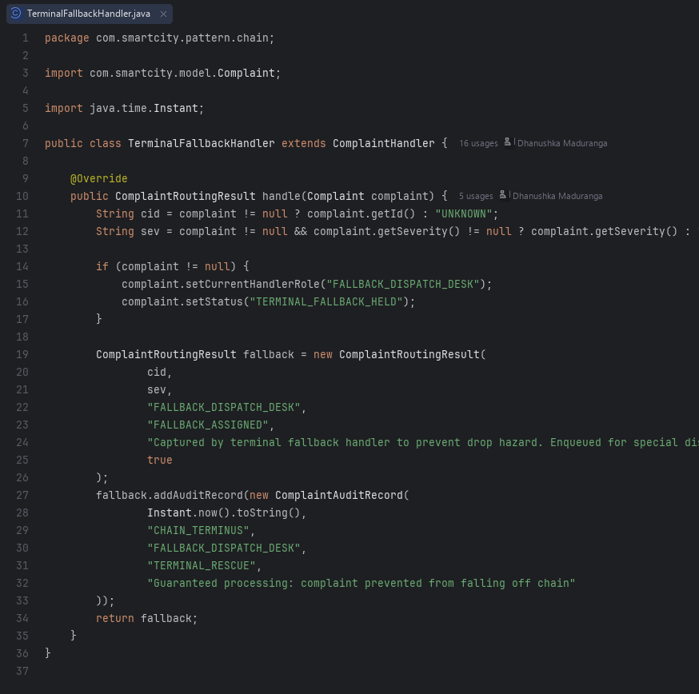  TerminalFallbackHandler.java | 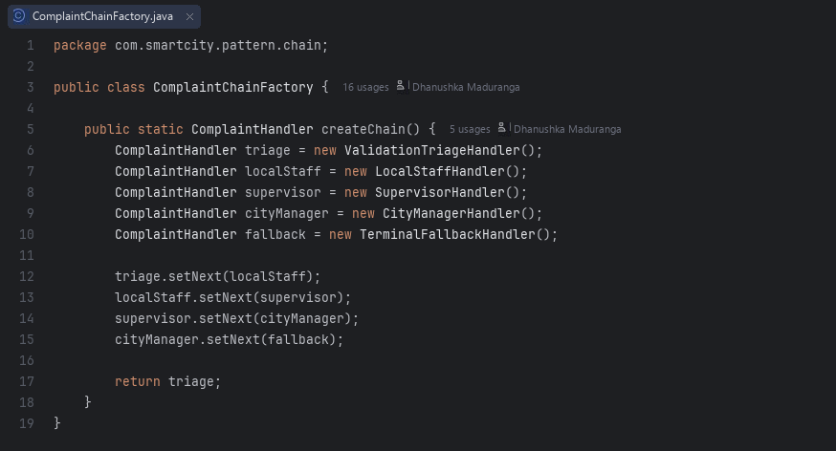  ComplaintChainFactory.java

A.4 Flyweight (com.smartcity.pattern.flyweight)
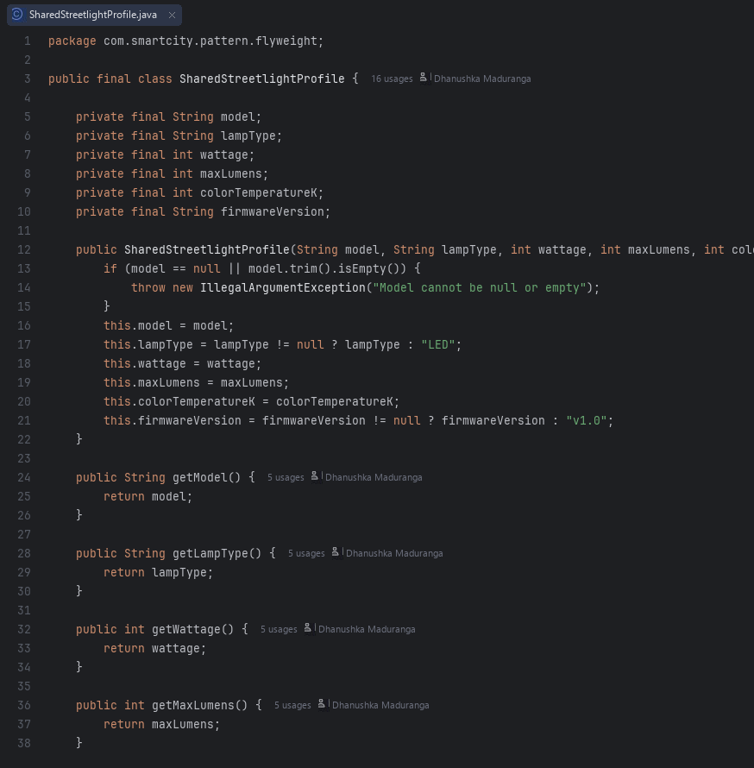  SharedStreetlightProfile.java | 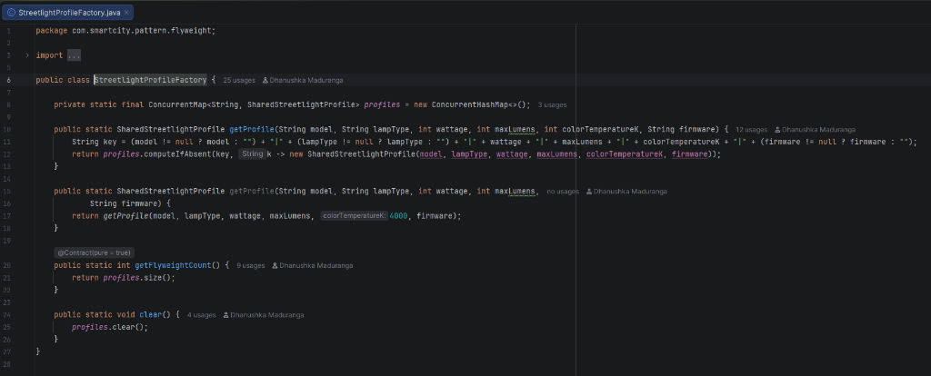  StreetlightProfileFactory.java
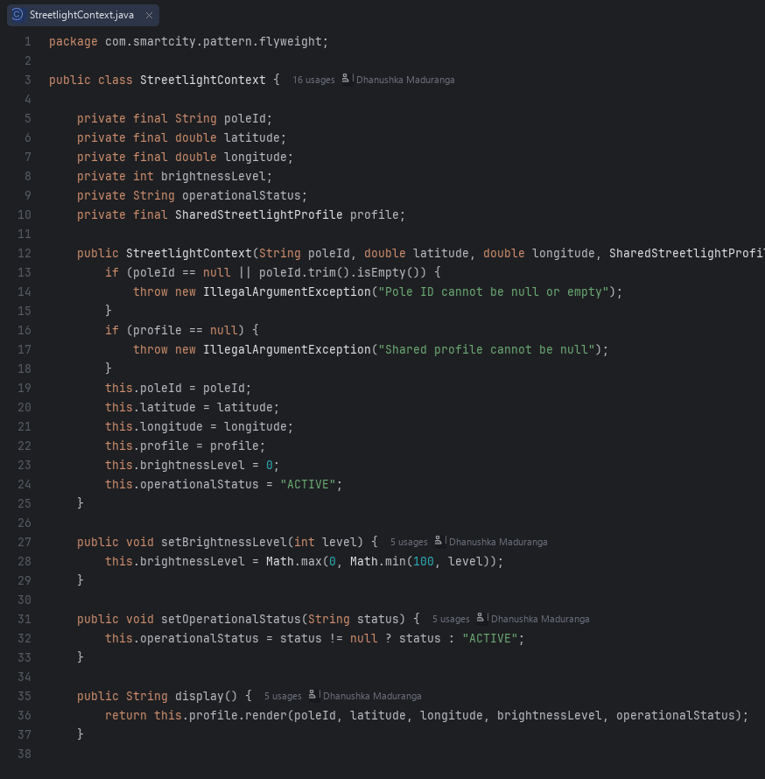  StreetlightContext.java | 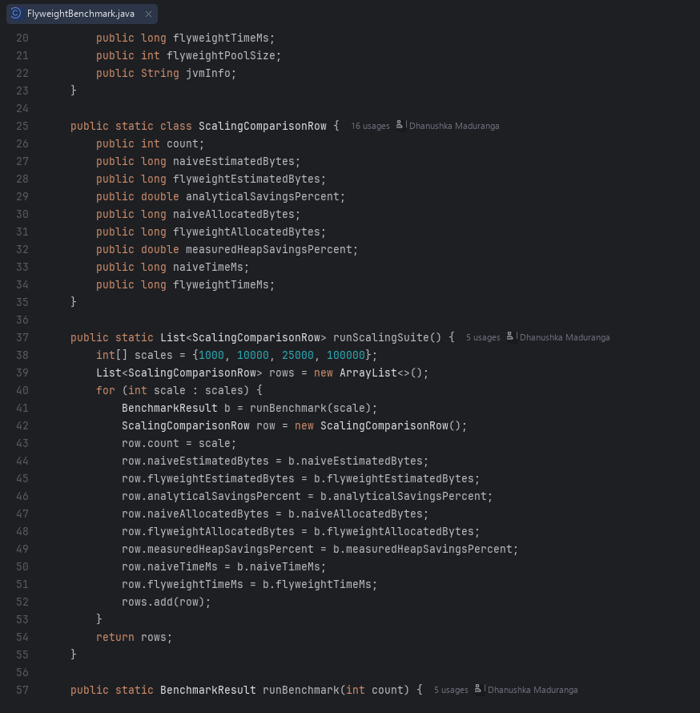  FlyweightBenchmark.java

A.5 Interpreter (com.smartcity.pattern.interpreter)
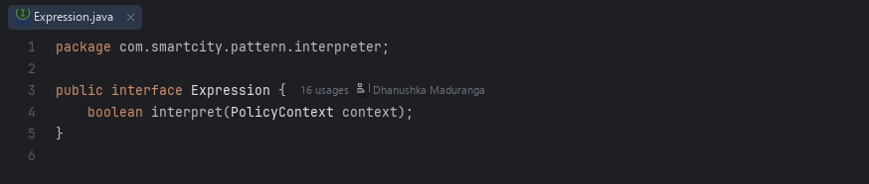  Expression.java | 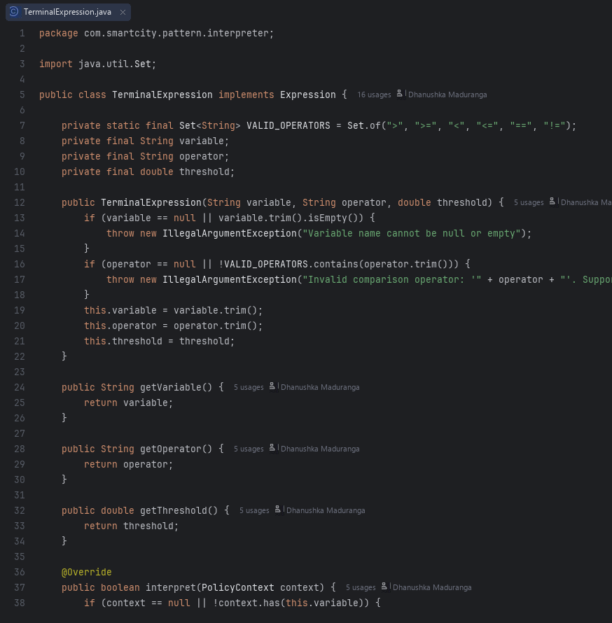  TerminalExpression.java
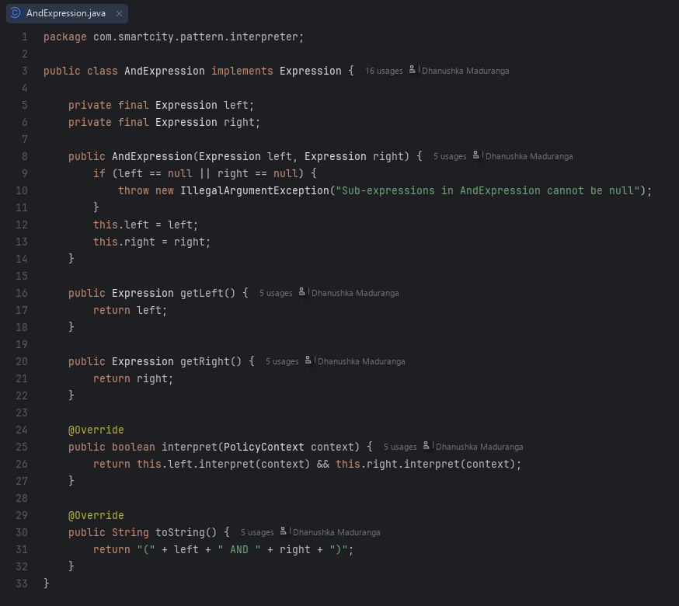  AndExpression.java | 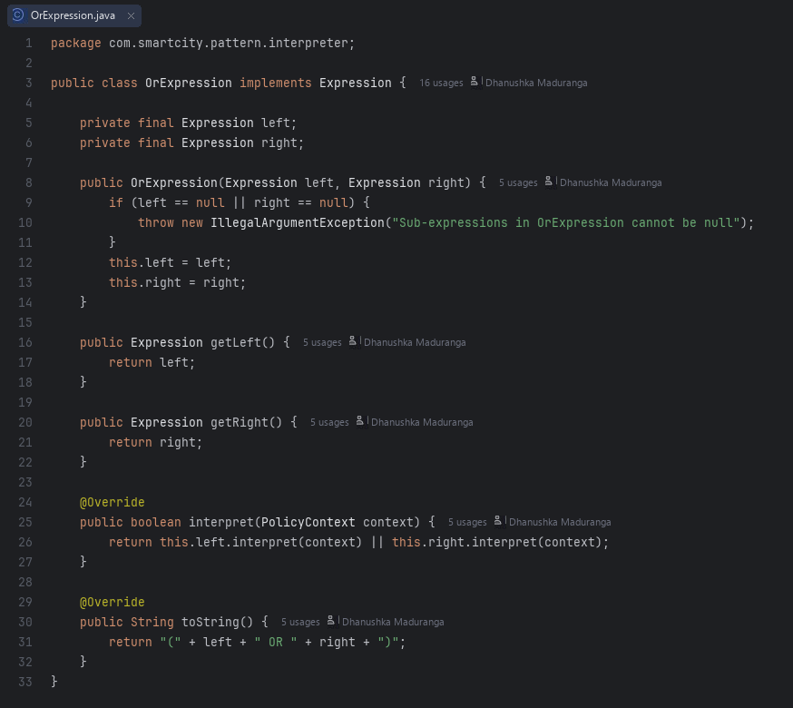  OrExpression.java
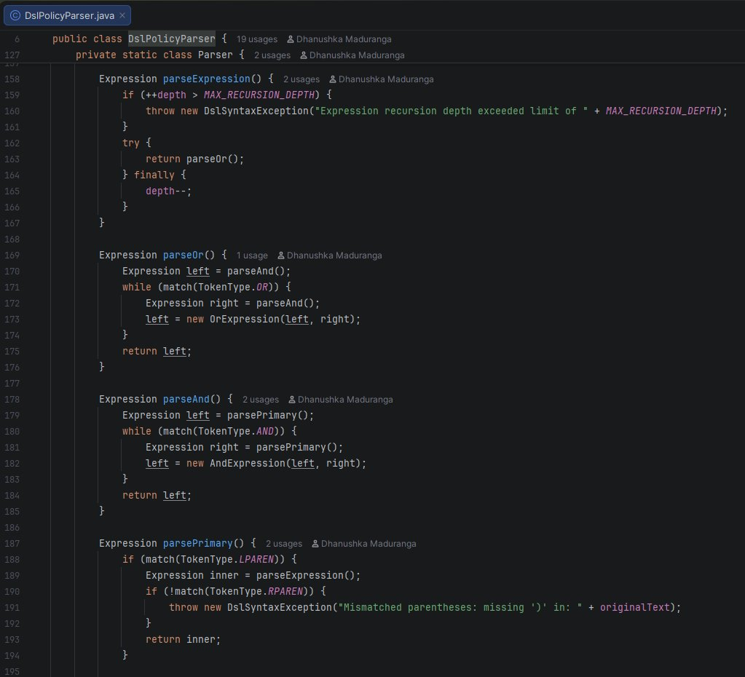  DslPolicyParser.java | 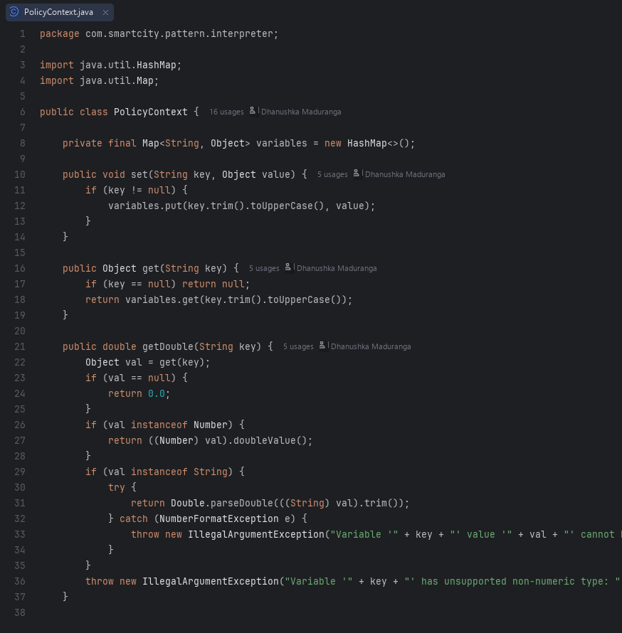  PolicyContext.java

